INTERGOVERNMENTAL AGREEMENT

BETWEEN

TOWN OF BLOOMING GROVE and CITY OF MADISON

The parties to this Intergovernmental Agreement (the “Agreement”) are the Town of Blooming Grove, Dane County, Wisconsin (the “Town”), and the City of Madison, Dane County, Wisconsin (the “City”).

RECITALS

A. The Town and the City are adjacent to one another and have a long history of disputes regarding boundaries and the provision of municipal services. Prior annexations to the Cities of Madison and Monona and the Village of McFarland have fragmented the Town, and potential and future annexations to the City make uncertain the long term viability of the Town as a separate governmental entity. This Agreement determines the Town’s future with certainty, resolves potential disputes over Town territory, and establishes a basis for future governmental cooperation, providing for an orderly transition of Town territory to the City and the Village, and preserves the Town’s viability while it remains a Town.

B. The City desires that existing and new development in the Town north of Siggelkow Road be compatible with the City and eventually be assimilated by the City, and that all other development shall occur in the City, served by City municipal services and in compliance with applicable City development standards.

C. The Town and the City desire to enter into this Agreement for the general purposes of guiding and accomplishing a coordinated, adjusted, and harmonious development of the Town and the City and transition from Town to City which will be in accordance with existing and future needs of the Parties and best promote public health, safety, morals, order, convenience, prosperity and the general welfare of the Parties and their residents as well as the efficiency and economy of the Parties.

D. The Town and the City believe that:

(1) The annexations and boundary changes governed by this Agreement are reasonably compatible with the characteristics and adopted plans of both Parties taking into consideration present and potential transportation, sewer, water and storm drainage facilities and other infrastructure, fiscal capacity, previous political boundaries, boundaries of school districts and shopping and social customs.

(2) The annexations and boundary changes governed by this Agreement are not the result of arbitrariness and reflect due consideration of compactness of area, orderly urban growth, and efficient delivery of municipal services.

(3) Entering into this Agreement should not produce significant adverse environmental consequences to the natural environment and may help reduce significant adverse environmental consequences to the natural environment by promoting the orderly and coordinated development of the lands hereby affected.

(4) This Agreement is generally consistent with current state and federal laws, shoreland zoning ordinances, municipal regulations and administrative rules that apply in the Town and the City.

(5) This Agreement adequately addresses the delivery of necessary municipal services to the residents affected by this Agreement.

AGREEMENT

NOW THEREFORE, for good and valuable consideration, the receipt and sufficiency of which is hereby acknowledged, and in accordance with the authority granted them under the Wisconsin statutes and for their mutual benefit and in the public interest, the Town and the City agree as follows:

- Town Protected until October 31, 2027.

  - Protected Period. The Town shall remain a town until 11:59 p.m. on October 31, 2027 (the “Protected Period”). During the Protected Period, annexations and boundary changes shall occur only in strict conformance with Section 2 of this Agreement. At 11:59 p.m. on October 31, 2027 (the “Transition Date”), the Protected Areas and all territory remaining in the Town shall become part of the City. Except for the final transfer of assets and liabilities from the Town to the City, no payments or revenue sharing between the Parties shall continue after the Transition Date.

  - Early Termination of Protected Period. On or after January 1, 2019, the Town may, upon a 4/5 vote of the Town Board, elect to have all of the territory remaining in the Town become a part of the City upon at least fifteen months’ written notice to the City, unless a different notice period is agreed to by the Parties, by designating an earlier Transition Date and thereby shortening the Protected Period.

- Annexation, Phased Annexation Areas, Protected Areas, and Rustic Acres

  - Annexation Areas.

    - During the Protected Period, in accordance with state law as modified by this Agreement, and except for territory within the Protected Areas specified in section 2.C. of this Agreement, the City may annex territory from the Town in accordance with this Agreement. The Village of McFarland may annex lands south of Siggelkow Road in accordance with state law.

    - Except as expressly allowed in this Agreement, the City shall not annex any territory from the Town contrary to the wishes of any owners of the parcels proposed for annexation. Approval of resident electors shall not be required for any annexations to the City.

    - The Town shall not oppose any annexation permitted by this Agreement or provide support, financial or otherwise, to those who do.

    - Annexations permitted by this Agreement may create “town islands.” Town island means territory in the Town completely surrounded by City territory.

    - Except as provided otherwise in this Agreement, revenue sharing for all annexations of Town territory during the term of this Agreement shall be for five (5) years as provided for annexations under 2003 Wisconsin Act 317.

  - Phased Annexation Areas.

All or part of Town territory east of the western right-of-way line of Interstate 39/90 as described in the description and shown on the map attached hereto as Exhibit A (the “North and South Phased Annexation Areas”), except territory in Rustic Acres and the Protected Areas as described in subsections C. and D. below, is subject to early annexation to the City, without the consent of property owners or electors, as follows:

    - All or part of Town territory east of the western right-of-way line of Interstate 39/90 and north of the northern Chicago & Northwestern Railroad right-of-way line described and shown on Exhibit A (the “North Phased Annexation Area”) that has not been voluntarily annexed to the City by January 1, 2015 may become a part of the City as follows:

At any time between January 1, 2015 and August 31, 2015, the City, upon a 2/3 vote of the elected members of the City’s Common Council, may adopt an ordinance annexing such territory. The annexation shall be effective as of 12:01 a.m. on the last Monday in December 2015. Unless otherwise agreed to by the Parties in writing, if the Town gives written notice to the City Clerk between January 1, 2015 and April 30, 2015 reminding the City of the City’s right to annex under this subsection, then the City shall lose the right if it is not exercised by August 31, 2015. If the Town fails to give such notice and the City fails to exercise its right, then the City may, by June 30 of any year after 2015, adopt an ordinance annexing such territory effective at 12:01 a.m. on the last Monday in December of the same year.

As a complete alternative to the City adopting an ordinance annexing such territory as provided in this Section 2.B.(1), the City and the Town may agree in writing to a different schedule for annexing all or part of such territory to the City after January 1, 2015.

    - All or part of Town territory east of the western right-of-way line of I-39/90, south of the northern Chicago & Northwestern Railroad right-of-way line and north of Siggelkow Road described and shown on Exhibit A (the “South Phased Annexation Area”) that has not been voluntarily annexed to the City by January 1, 2020 may become a part of the City as follows:

At any time between January 1, 2020 and August 31, 2020, the City, upon a 2/3 vote of the elected members of the City’s Common Council, may adopt an ordinance annexing such territory. The annexation shall be effective as of 12:01 a.m. on the last Monday in December 2020. Unless otherwise agreed to by the Parties in writing, if the Town gives written notice to the City Clerk between January 1, 2020 and April 30, 2020 reminding the City of the City’s right to annex under this subsection, then the City shall lose the right if it is not exercised by August 31, 2020. If the Town fails to give such notice and the City fails to exercise its right, then the City may, by June 30 of any year after 2020, adopt an ordinance annexing such territory effective at 12:01 a.m. on the last Monday in December of the same year.

As a complete alternative to the City adopting an ordinance annexing such territory as provided in this Section 2.B.(2), the City and the Town may agree in writing to a different schedule for annexing all or part of such territory to the City after January 1, 2020.

    - Early annexations with the consent of the property owner are also permissible within the North and South Phased Annexation areas. Approval of resident electors shall not be required.

    - Notwithstanding any amendment of the statutes subsequent to the effective date of this Agreement, the City shall be responsible for the services in the annexed territory beginning on the effective date of the annexation, and the Town shall be entitled to revenue sharing as specified in subsection 2.A(5) of this Agreement.

    - The lands currently in the Town and owned by the Ho-Chunk Nation, or any wholly owned corporation or subsidiary thereof, located south of Millpond Road, together with certain highway right of way segments described in the legal description and shown on the map attached hereto as Exhibit B shall be annexed to the City by adoption of an ordinance by a majority of the elected members of the City’s Common Council. Such ordinance shall become effective upon final State approval of a cooperative plan incorporating the terms of this Agreement. This provision is intended to implement the annexation requirement set forth in section 2 of the Intergovernmental Service and Development Agreement Between the City of Madison and the Ho-Chunk Nation, dated August 25, 1998 and effective September 10, 1998.

  - Protected Areas.

During the Protected Period, the City shall not annex any territory from the following areas in the Town that are described in the descriptions and shown on the map attached hereto and incorporated herein as Exhibit C (the “Protected Areas”): Gallagher Plat; Gallagher Garden; April Hill Subdivision; Rambling Acres Subdivision; Freeway Manor; Weather Oaks; the existing developed business and commercial areas along highway 12/18.

  - Rustic Acres.

    - The area known as “Rustic Acres” in the northeast portion of the Town is shown and described in the map and description attached hereto and incorporated herein as Exhibit D. During the Protected Period, the City may annex territory in Rustic Acres, in accordance with the provisions of Section 2.A. of this Agreement. Rustic Acres is not included in the North Phased Annexation Area of Section 2.B.(1) of this Agreement.

    - Development of Annexed Rustic Acres Territory. In the event the City annexes territory in Rustic Acres after the Effective Date of this Agreement, development shall be allowed as follows:

a. Lots in Rustic Acres in existence on the Effective Date of this Agreement that are immediately adjacent to Milwaukee Street or Sprecher Road may be developed in compliance with the City’s neighborhood development plan or other land use, master or comprehensive plans in effect at the time such lots are developed.

b. For all other lots in Rustic Acres in existence on the Effective Date of this Agreement, development shall be limited to residential land uses and necessary associated improvements including roads, utilities, parkland, and other governmental uses. Residential densities shall be limited to an average of 8 units per net acre of development. Residential development shall be limited to single family detached dwellings and two-family dwellings. The height of residential structures shall be limited to 35 feet

  - Capital Springs Centennial State Park.

The Town currently receives aids from the Wisconsin Department of Natural Resources (“WDNR”) equivalent to property taxes pursuant to Wis. Stat. § 70.114 for Capital Springs Centennial State Park (“Aids”). In the event that all or part of the area known as Capital Springs Centennial State Park (as it currently exists or as it exists in the future in the Town) is annexed to the City, the City shall pay the Town the portion of the Aids payment received by the City for the annexed land beginning in the year after the annexation is effective and the WDNR stops paying the Aids to the Town and for each year thereafter during the remainder of the Protected Period. In the event that Town territory is annexed to the City for which the City is making revenue sharing payments pursuant to Section 2.A.(5) of this Agreement and such territory becomes a part of the Capital Springs Centennial State Park subsequent to annexation and is therefore tax exempt, upon such territory becoming a part of the State Park, the City shall no longer make revenue sharing payments for such territory, pursuant to Section 2.A.(5), but shall pay the Aids attributable to the territory to the Town for the period of time the City would have made revenue sharing payments.

- Town Retains Governmental Authority

Except as otherwise provided in this Agreement, the Town retains full and independent governmental authority throughout the Town during the Protected Period. The Town shall exercise that authority in good faith in order to protect the Town’s interests and to assure that the Town’s finances and property are in reasonable condition for transfer to the City at the end of the Protected Period.

- Cooperative Development of Property in the Town

  - As used in this Section 4, “develop” or “development” refers to division of land, or construction of more than one principal structure on a parcel of land, or rezoning a parcel from a residential or agricultural classification to a non-residential classification. Use or division of land by the Town or City for governmental purposes does not constitute development. All development in the Town shall be subject to conditional approval by the City in accordance with the City’s adopted ordinances, plans, policies, standards and procedures (“City Development Requirements”). City Development Requirements include, but are not limited to, all adopted neighborhood development plans, land use, master or comprehensive plans, the Land Subdivision Regulations Ordinance (Sec. 16.23, Madison General Ordinances (“MGO”), Impact Fee Ordinance (Chapter 20, MGO), and the Public Stormwater System Including Erosion Control Ordinance (Chapter 37, MGO). All new or replacement signs, billboards or street graphics in the Town shall comply with the restrictions of the Madison Street Graphics Control Ordinance (Chapter 31, MGO) and with the applicable Dane County sign regulations. In the event of a conflict between the City and Dane County sign regulations, the more restrictive regulations shall apply.

(1) The City and the Town specifically agree to work cooperatively on the joint planning and development of properties north of Milwaukee Street and along North Fair Oaks Avenue (the “Development Property”). The Development Property is described in the legal description and shown on the diagram attached hereto and incorporated herein as Exhibit E. The City and the Town shall cooperate to establish zoning over the Development Property, pursuant to the procedure attached hereto and incorporated herein as Exhibit F, to allow the development of the Development Property while the Development Property is in the Town, consistent with the Town’s land use plan and the City’s comprehensive plan in effect at the time zoning is established. At the present time, those plans would allow development for residential single family and multi-family use, including senior elderly housing, and some limited amount of mixed uses including neighborhood commercial uses, and associated improvements including roads, utilities, parkland, multipurpose trails, wetlands, other open spaces, ponds, and other governmental uses. The zoning established by the Parties will be effective in the City when the Development Property is annexed to the City pursuant to this Agreement. Any new construction of principal structures or development of the Development Property shall require the review and approval of both the Town and the City and, unless the Parties agree otherwise, shall be conditioned upon compliance with City Development Requirements. As long as the anticipated value of the improvements to the Development Property is at least $10,000,000, upon full build-out of the development, including all phases of the development, the City shall extend public water and sewer services to the Development Property in advance of annexation in order to support development approved by the City and the Town.

(2) In the event new principal structures are constructed on the Development Property or the Development Property is developed after the Effective Date of this Agreement, the Development Property shall remain in the Town and shall not be annexed to the City for a period of time that is equal to approximately one-half of the period of time between: (a) the “Occupancy/Assessment Date,” which is the date upon which an occupancy certificate/permit has been issued for new principal structures on the Development property and the assessed or appraised value of the new principal structures (excluding the value of public improvements such as streets or water and sewer facilities) is $2,000,000.00 (Two million dollars) as jointly determined by the City’s property tax assessor and the Town’s property tax assessor; and (b) the Transition Date. In the event that the City’s property tax assessor and the Town’s property tax assessor cannot agree on the assessed or appraised value of the new principal structures on the Development Property, the Parties shall jointly choose a third party with the appropriate experience to determine the assessed or appraised value of the new principal structures on the Development Property. The Development Property shall be automatically annexed to the City effective as of 12:01 a.m. on the last Monday in December in the year which is closest to the mid-point between the Occupancy/Assessment Date and the Transition Date (the “Development Property Base Year”). In the event that no new principal structures are constructed on the Development Property or the Development Property is not developed after the Effective Date of this Agreement, the Development Property shall remain in the Town until the Transition Date.

(3) In lieu of the revenue sharing for annexations provided in section 2.A(5) of this Agreement, the Town shall keep 100% of the local government share of tax revenues collected by the Town for the Development Property while the Development Property is in the Town and for the Development Property Base Year (“base year revenue sharing amount”). Payments received by the Town in lieu of taxes, if any, shall not be included in the base year revenue sharing amount, and the City shall receive any and all such payments in lieu of taxes following annexation of the Development Property as long as the City is responsible for providing the municipal services covered by such payments. Additionally, the City shall pay the Town 70% of the base year revenue sharing amount from taxes it collects from the Development Property for the tax year after the Development Property Base Year; and 50% of the base year revenue sharing amount from taxes it collects for the second year after the Development Property Base Year. Payments are due in two equal installments: the first due on February 15 and the second due on August 15 of the second and third years after the year of attachment, respectively.

  - The division of a 5-acre or larger parcel existing in the Town as of the Effective Date of this Agreement into only two lots for residential purposes shall not be considered “development” under section 4.A. of this Agreement, and the owners may divide and rezone the parcel to a single-family residential district and construct a single-family residence on each new lot without the cooperation or approval of the City. A “parcel” is defined as the contiguous lands within the control of a single owner.

- Public Improvements and Utilities

  - The City shall use public highway rights-of-way to extend municipal services wherever reasonably possible. The Town shall permit use of Town roads for such purpose, subject only to the City’s obligations to maintain access for emergency vehicles and owners and occupants of property in the Town and to restore the road upon completion of construction. Where the City cannot use public highways for extensions of services, the Town acknowledges the City’s right to obtain easements from private property owners subject to compensation as required by state law.

  - The City may levy special assessments against any parcel of property in the Town for public improvements that specially benefit the parcel. The Town hereby approves such future levies, under Sec. 66.0707, Wis. Stats. In the event that this blanket pre-approval provision is either not approved by the State Department of Administration or invalidated by a court of competent jurisdiction, the Town further agrees, to the extent it may lawfully do so, that it shall timely approve each such special assessment levy by separate resolution pursuant to said statute.

    - The owner or other interested party may challenge such special assessments as an owner of property in the City would have the right to do.

    - Payment of such special assessments shall be deferred and interest shall not accrue thereon until the parcel is annexed to the City.

    - Notwithstanding paragraph (2) above, the amount of each such special assessment shall be adjusted from the date of levy to the date of annexation based on the Engineering News Record Construction Cost Index, or such equivalent index as may be available at the time of annexation.

    - Each such special assessment shall be payable in six annual installments with interest, from the date of annexation.

    - Prior to annexation, there shall be only one special assessment of each benefiting public improvement component (e.g. road pavement, curb and gutter, public sidewalk, street lights, street trees, traffic signals and other intersection improvement components, public drainage improvements, sanitary sewer mains, sewer interceptors, public water mains, etc.), except for driveway, curb and gutter and public sidewalk repairs which shall be billable to the abutting benefited property as special charges for current services rendered pursuant to Sec. 66.0627, Wis. Stats., and corresponding City ordinances and policies generally applicable to all property in the City. In accordance with Sec. 66.0707, Wis. Stats., the Town hereby pre-approves the levy of such future special charges by the City. In the event that this blanket pre-approval provision is either not approved by the State Department of Administration or invalidated by a court of competent jurisdiction, the Town further agrees, to the extent that it may lawfully do so, that it shall timely approve each such special charges levy by separate resolution pursuant to said statute. Any assessment subsequent to annexation for another improvement of the same component shall be made only if consistent with the City’s special assessment policy generally applicable to all property in the City. The first payment for such subsequent assessments shall be deferred with interest to a date not less than 10 years after annexation and the assessments shall be payable in six annual installments.

    - Additionally, the City may improve the following streets and levy special assessments against benefiting abutting parcels of property in the Town for curb and gutter and a 4 foot width of pavement and public sidewalk (if a sidewalk is reasonably necessary for public safety or convenience), in a manner consistent with the City’s special assessment policy generally applicable to property in the City, including City Resolution No. 58421, adopted June 19, 2001: Siggelkow Road; Mill Pond Road and Savannah Road; Femrite Drive; Buckeye Road/County Trunk AB/Brandt Road; Cottage Grove Road/County Trunk Highway BB; Sprecher Road (relocated) between Buckeye Road and Cottage Grove Road; Sprecher Road north of Cottage Grove Road, a portion of which will be relocated; Milwaukee Street; Rethke Avenue; Commercial Avenue service road (south of Wisconsin Highway 30); and Raywood Road. The City agrees that any improvements assessed under this provision will be materially the same for the Town portion of the street and the City portion of the street (for example, if sidewalks will be assessed, sidewalks will be installed on both the City and Town portions of the street) The payment of such special assessments shall not be deferred until the benefited parcel is annexed to the City. Each special assessment may be payable by 8 annual installments with interest, or, if required to meet the financial needs of the owner(s) of benefited parcels as determined by the City’s Board of Public Works, by no more than 15 annual installments with interest.

  - Notwithstanding section 5.B. above, any owner of property in the Town that is not in a Protected Area shall be entitled upon request to receive City sewer and/or water services prior to annexing the property to the City if the owner agrees to pay for extension of the services to the property over a five year period with interest and agrees to annexation of the property at the end of the five year period. Costs for extension shall be determined on the same basis as costs generally applicable for extensions to similarly situated property within the City. The annexation ordinance with a delayed effective date may be adopted prior to extensions. This paragraph applies only to parcels existing on the Effective Date of this Agreement. An owner’s entitlement to receive sewer and/or water services under this paragraph applies only to: existing uses on parcels as of the Effective Date of this Agreement; or new or expanded uses on existing parcels after the Effective Date of this Agreement, provided the new or expanded uses do not constitute development as defined in this Agreement. An owner of property in the Town that receives sewer services from the City shall be a customer of the Madison Sewer Utility and shall be billed in accordance with the applicable Madison General Ordinances. An owner of property in the Town that receives City sewer and/or water services shall become a customer of the Madison Stormwater Utility if the owner also connects directly into the City’s public stormwater system instead of into the Town’s public stormwater system, and shall be billed in accordance with the applicable Madison General Ordinances.

  - In the event the Town issues a plumbing permit for property located in the Town that is or will be connecting directly to City sanitary sewers, the Town shall use its best efforts to inform the property owner and plumber of the need to obtain any necessary approvals from the City’s sewer utility and shall notify the City’s sewer utility of the issuance of the plumbing permit.

- Job Continuity for Town Employees

The Town and the City shall cooperate to provide job security and job continuity for Town employees following the Protected Period. Any person who is a Town employee at the end of the Protected Period, shall be either: (1) offered suitable employment by the City on terms at least equivalent to those provided by Town employment; or (2) shall be paid a lump sum severance payment by the City according to the following schedule:

Duration of Town Employment  At the Time the Protected Period Expires |  |  | Amount of Severance Payment*  at Employee’s Town Rate of Pay
Less than 6 months |  |  |  | None
6 months or more and less than | 5 | Years |  | 3 | months’ pay
5 years or more and less than | 10 | Years |  | 6 | months’ pay
10 years or more and less than | 15 | Years |  | 9 | months’ pay
15 years or more |  |  |  | 1 | Year’s pay
*For purposes of calculating the severance payment, the amount of pay for the table above shall not exceed the level of pay for comparable positions in the City.
If a Town employee is employed by the City on a probationary basis and dismissed during the probationary period, but not for cause, the severance payment specified in the table above is due, less a credit for payments from the City to the employee during the period of City employment.
This severance benefit is the obligation of the City, and shall be paid by the City, not the Town.
- Intermunicipal Cooperation Agreement Between the City and the Village of McFarland

The City and the Village of McFarland, Wisconsin (“Village”), have entered into an agreement entitled “Intermunicipal Cooperation Agreement Between the City of Madison and the Village of McFarland relating to Lands Easterly of Marsh Road, Northerly of Eighmy Road, and Southerly of Siggelkow Road” dated November 26, 1997 (the “McFarland Agreement”). The McFarland Agreement has a term of 20 years, which expires on or about April 1, 2018. The McFarland Agreement provides in relevant part that no property south of Siggelkow Road and between School Street and County Highway AB (the “Southern Siggelkow Area”) shall be annexed to the City during the term of the McFarland Agreement. The Town acknowledges that the City and the Village may make arrangements prior to or after the expiration of the McFarland Agreement that would allow any property in the Southern Siggelkow Area that becomes a part of the City on the Transition Date pursuant to this Agreement, to be detached from the City and attached to the Village after the Transition Date.

- Good Faith Cooperation; Conversion to State-Approved Boundary Plan

  - The Town and the City shall cooperate in good faith to implement this Agreement, and may enter further agreements to facilitate an orderly transition of remaining Town territory to the City on the Transition Date. The Town and the City agree that they shall not hinder the performance and implementation of this Agreement in any way and that they will not oppose this Agreement in any way privately or publicly, either when communicating with any government agency which is charged with review and evaluation of any part of this Agreement, or otherwise.

B. The Town and City agree to pursue further cooperative agreements that will qualify each of them for additional shared revenues.

C. The Town and the City shall use their best efforts to secure timely State approval of a cooperative boundary plan under the provisions of Wis. Stat. § 66.0307, incorporating the terms of this Agreement. Reference in this Agreement to “annexation” includes summary attachment procedures as part of a State-approved cooperative boundary plan.

D. The Town and the City agree that a party’s failure to comply with subsections A or C in this Section 8 will do substantial harm to the other party, that the amount of actual damages may be difficult or impossible to establish, and that $250,000 is a reasonable estimate of what such damages may be. Accordingly, if either party breaches subsection A or C of this Section 8, that party shall be liable to the other party in the amount of $250,000 in the form of liquidated damages or that Party’s actual damages, whichever is greater. The breaching party shall also be liable to the other party for the other party’s actual attorney fees and costs to enforce this provision.

- Stormwater Management

The Agreement does not alter any rights the Town and the City have to continue to discharge public stormwater into the public stormwater system of the other Party; nor does this Agreement require either Party to upgrade its respective public stormwater system. Except as otherwise agreed, the Town and the City shall be responsible for maintaining the public stormwater system located in their respective jurisdictions. Owners of property in the Town requesting direct connection to the City’s stormwater system shall be allowed to connect thereto, subject to becoming a customer of the Madison Stormwater Utility. Owners of property in the Town that have connected to the City’s stormwater system without City permission shall, within 6 months of the date of this Agreement, either become a customer of the Madison Stormwater Utility or shall remove their connection. The City shall be responsible for notifying the owners of the property that are connected without City permission of this provision and for enforcing this provision. The Parties are individually responsible for stormwater management in their respective jurisdiction, and for the Party’s compliance with applicable stormwater management regulations, including Wisconsin Administrative Code Chapter NR 216 and WPDES Permit No. WI-S058416-2. The City and the Town may work cooperatively with regard to complying with applicable stormwater management regulations by sharing or further contracting with each other for services such as street sweeping, catch basin cleaning, or the maintenance of retention pond facilities.

- Millpond Road

The City shall perform the following maintenance and improvement responsibilities for Millpond Road:

  - The City shall have the maintenance responsibility within the Millpond Road right-of-way from City limits west of the intersection with Savannah Road, west to the City limits at Evan Acres Road. Such maintenance responsibility shall include maintenance of pavement and drainage ditches, snowplowing, regulation of street and driveway access control for private properties in the City, and regulation of utilities. The Town shall retain street and driveway access control for private properties in the Town, and for traffic signing and marking as long as this road segment remains in the Town.

  - At such future time, as determined by the City, that Millpond Road is reconstructed to urban standards, the Town and City agree to jointly share the cost of the improvements, which shall be divided between the Town and the City based upon the frontage of abutting properties in each jurisdiction. The prorated local share may be financed, in whole or in part, as a special assessment, or from the general revenues of each municipality, as determined in the sole discretion of each municipality. If assessed, the Town shall adopt a resolution levying the assessments in accordance with Wis. Stat § 66.0703.

11. Ho-Chunk Nation Trust Property

The City shall keep the Town informed of the development and processing of development plans for the Ho-Chunk Nation Trust Lands and Fee Lands, located adjacent to Millpond, Evan Acres and Savannah Roads in the City, and allow the Town and/or its designee to review and comment on the plans.

12. Cooperation Concerning Quarries and Non-Metallic Mines

The Town and the City will reasonably cooperate to find mutually acceptable solutions to issues concerning the operation of quarries and non-metallic mines located on parcels that are adjacent to the City.

13. Disputes Settled by Arbitration

Except as to liquidated damages under Section 8.D., disputes over compliance with this Agreement shall be resolved by binding arbitration. Mediation may be used prior to arbitration if both Parties agree. A Party may initiate legal proceedings in a court of competent jurisdiction in order to enforce an award or decision obtained in binding arbitration.

14. Binding Effect

This Agreement shall bind, and accrue to the benefit of, all successors of the Parties. Except as to the rights of owners of land currently in the Town as expressly set forth herein, this Agreement is for the exclusive benefit of the Parties and their successors and assigns and shall not be deemed to give any legal or equitable right, remedy, or claim to any other person or entity.

15. Recording

The Parties shall cause a notice of this Agreement to be recorded in the office of the Register of Deeds. The cost to record the notice shall be split equally by the Town and the City.

16. Challenge to Agreement

  - Both Parties waive all rights to challenge the validity or enforceability of this Agreement or any of its provisions or to challenge any actions taken pursuant to or in accordance with this Agreement.

  - In the event of a court action by a third party challenging the validity or enforceability of this Agreement or any of its provisions, both Parties shall fully cooperate to vigorously defend this Agreement.

    - If only one Party is named as a party to the action, the other shall seek to intervene and the named Party shall support such intervention.

    - No settlement of such an action shall be permitted without the approval of the governing bodies of both Parties.

    - The workload to defend this Agreement shall be shared equally.

  - A challenge to this Agreement by one of the Parties or a failure to vigorously defend this Agreement constitutes a breach of this Agreement.

17. Remedies

In addition to other remedies provided in this Agreement,

  - Either Party may seek specific performance of this Agreement in addition to any other remedies available at law or in equity.

  - The breaching Party shall pay the other’s attorney fees reasonably incurred in seeking remedies for the breach.

18. Term

The term of this Agreement shall commence on the Effective Date and shall terminate upon all Town territory becoming part of the City pursuant to Section 1 of this Agreement.

19. Effective Date

The Effective Date shall be the date when this Agreement is executed by the authorized representatives of the Parties following approval by the governing bodies of both Parties.

20. Entire Agreement

This Agreement contains the entire agreement of the Parties with respect to the subject matter hereof, and all prior discussions, drafts, agreements, and writings are specifically superseded by this Agreement. This Agreement supersedes the agreement titled “Annexation, Jurisdiction and Service Agreement Between the City of Madison, the Town of Blooming Grove and the Blooming Grove Sanitary District No. 8,” dated April 6, 1995. The Parties acknowledge that Blooming Grove Sanitary District No. 8 no longer exists. This Agreement represents the mutual intent of the Parties and the fact that one or more of its provisions was drafted by one party or another shall not be construed to the benefit or detriment of either party.

21. Authority

Each party represents that it has the authority to enter into this Agreement and that all necessary procedures have been followed to authorize this Agreement. Copies of the resolutions of the governing bodies of both Parties, authorizing this Agreement are attached hereto as Exhibits G and H. Each person signing this Agreement represents and warrants that he or she has been duly authorized to do so.

22. Counterparts

This Agreement may be signed in counterparts which, when taken together, shall be effective as if all signatures appeared on the same original.

23. Non-Discrimination

In the performance of the obligations under this Agreement, the Parties agree not to discriminate against any employee or applicant because of race, religion, marital status, age, color, sex, handicap, national origin, ancestry, income level, source of income, arrest record, conviction record, less than honorable discharge, physical appearance, sexual orientation, political beliefs, or student status. The Parties further agree not to discriminate against any subcontractor or person who offers to subcontract under this Agreement because of race, religion, color, age, disability, sex, or national origin.

Dated this 18th day of February, 2005.

TOWN OF BLOOMING GROVE
Dane County, Wisconsin

By:____________________________________
Tom N. Anderson, Chair

Attest:

_____________________________________
Audrey Rue, Town Clerk/Treasurer
Approved as to Form:

____________________________
Richard K. Nordeng, Town Attorney

Dated this 18th day of February, 2005.

CITY OF MADISON
A Wisconsin municipal corporation

By: _____________________________________
David J. Cieslewicz, Mayor

By: ___________________________________
Ray Fisher, City Clerk

Countersigned:

______________________________
Dean Brasser, City Comptroller

Approved as to Form:

________________________
Michael P. May, City Attorney

Attachments
Exhibit A - Description and Maps of North and South Phased Annexation Areas
Exhibit B - Legal Description and Map of Ho-Chunk Nation Property
Exhibit C - Description and Maps of Protected Areas
Exhibit D - Description and Map of Rustic Acres
Exhibit E - Legal Description and Map of the Development Property
Exhibit F - Joint Zoning Procedure for the Development Property
Exhibit G - Authorizing Resolution of Town of Blooming Grove Town Board
Exhibit H - Authorizing Resolution of City of Madison City Council

Exhibit A
Description and Maps of
North and South Phased Annexation Areas

Description of North Phased Annexation Area (as shown on Exhibit “A” North):

All or part of Town territory east of the western right-of-way line of Interstate 39/90 and north of the northern Chicago & Northwestern Railroad right-of-way line, that has not been voluntarily annexed to the City by January 1, 2015.

Description of the South Phased Annexation Area (as shown on Exhibit “A” South):

All or part of Town territory east of the western right-of-way line of Interstate 39/90, south of the northern Chicago & Northwestern Railroad right-of-way line and north of Siggelkow Road, that has not been voluntarily annexed to the City by January 1, 2020.

NOTE: The Phased Annexation Areas do not include territory in Rustic Acres and the Protected Areas.
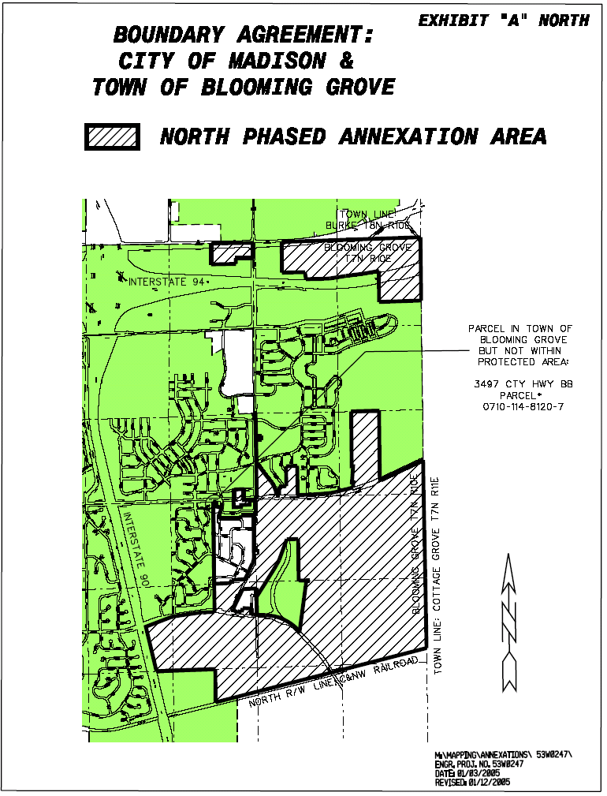
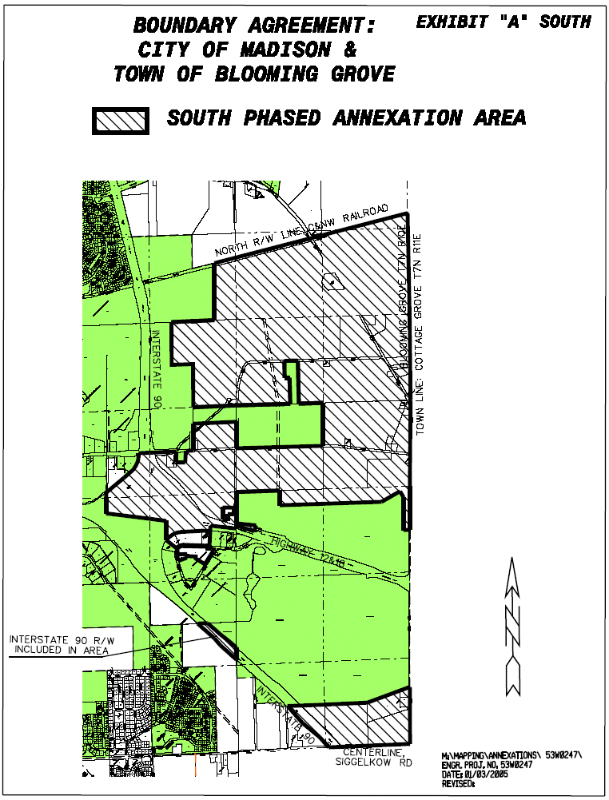
exhibit b
legal description and map of
the ho-chunk nation property

Lot 6, Assessor’s Plat No. 10, Town of Blooming Grove, except that part of Lot 6 described in Document No. 3135154, Dane County Registry, and including part of the southerly and easterly right-of-way of Millpond Road as platted on said Assessor’s Plat, all located in the South 1/2 of the Northeast 1/4 of Section 26, Township 7 North Range 10 East, Town of Blooming Grove, Dane County, Wisconsin, to wit:

Commencing at the southwest corner of Lot 6, Assessor’s Plat No. 10, Town of Blooming Grove, being also a point on the easterly right-of-way of Millpond Road as platted on said Assessor’s Plat; thence S87°47’E, 318.73 feet along the southerly line of Lot 6 to the northeast corner of said Lot 13; thence S02°13’W, 65.00 feet along the east line of Lot 13 of said Assessor’s Plat, to the southerly line of said Lot 6; thence along the southerly line of Lot 6 for the next three courses: (1) S87°47’E, 266.27 feet; (2) S02°13’W, 62.20 feet; and (3) S57°47’30”E, 330.45 feet to the northwesterly right-of-way line of Savannah Road; thence N32°12’30”E, 479.97 feet along said northwesterly right-of-way to the south corner of lands described as “Parcel 3” in Document No. 3135154, Dane County Registry; thence along the westerly line of said “Parcel 3”, being the existing westerly right-of-way line of Savannah Road, for the next three courses: (1) northwesterly along the arc of a 25.00 foot radius curve to the left whose long chord bears N04°52’56”W, 30.15 feet; (2) N41°58’22”W, 43.11 feet to a point of curve; and (3) northwesterly along the arc of an 85 foot radius curve to the left whose long chord bears N63°33’41”W, 62.55 feet to the north line of said Lot 6 and existing southerly right-of-way of Millpond Road; thence N85°09’W, 4.43 feet along said north line of Lot 6 and southerly right-of-way line to an angle point in the north line of said Lot 6; thence N87°47’W, 74.13 feet along said north line of Lot 6 and southerly right-of-way line; thence N02°13’E, 35.00 feet along the existing city limits as defined in Madison Common Council Ordinance No. 12461, ID No. 25942, adopted Aug. 17, 1999, to the centerline of Millpond Road; thence N87°47’W along the centerline of Millpond Road, 731.73 feet to a point of tangent curve; thence southwesterly on said centerline along the arc of a 245.00 foot radius curve to the left whose long chord bears S65°13’W, 222.46 feet, to the southeasterly prolongation of the northeasterly line of Lot 1, Certified Survey Map No. 729; thence S51°47’E along said prolongation, 35.00 feet to the southeasterly right-of-way line of Millpond Road and westerly line of said Lot 6; thence southwesterly on said right-of-way line and westerly line of Lot 6, along the arc of a 210.00 foot radius curve to the left whose long chord bears S20°13’00”W, 129.79 feet to the point of beginning. Containing 352,700 square feet or 8.097 acres, more or less.

Tax Parcel Numbers included in description:
#0710-261-6177-6
#0710-261-6216-8

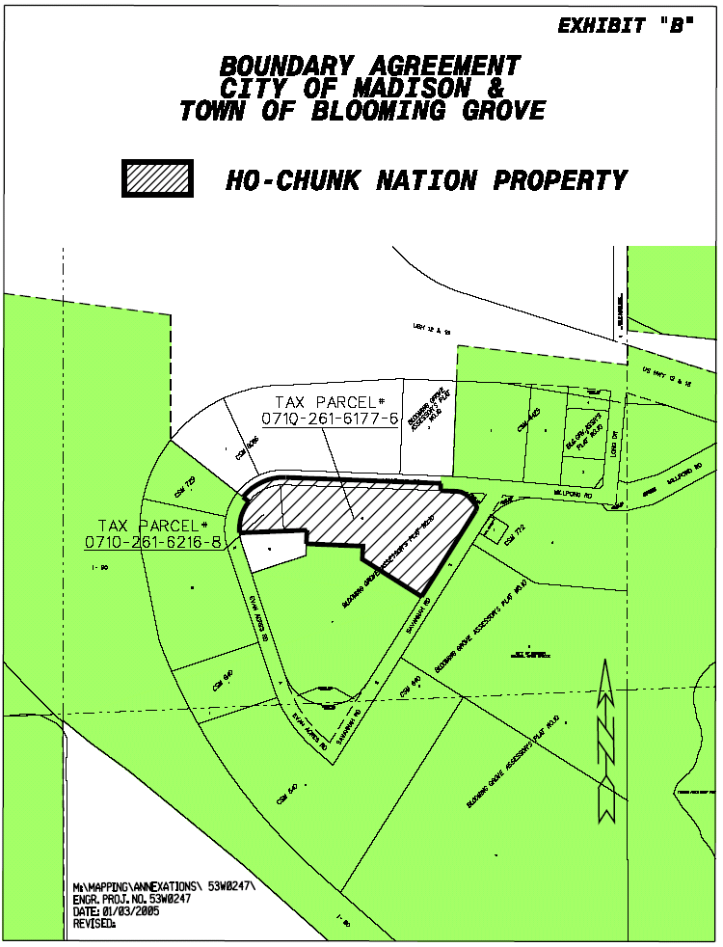
Exhibit C
Description and Maps of Protected Areas

Description of the Protected Areas:

All territory in Clyde A. Gallagher’s Plat (Being Lots 347-382), all territory in Elisha L. Gallagher Plat, all territory in Second Addition to Elisha L. Gallagher Plat, all territory in Replat of Block 9 of Second Addition to Elisha L. Gallagher Plat, all territory in Replat of Part of Block 14, and all of Blocks 12, 13, 11, 15 & 16, Second Addition to Elisha L. Gallagher Plat , part of the Clyde A. Gallagher Park Subdivision (Being Lots 383-481) except Lots 425 to 429 inclusive, and part of First Addition to Clyde A. Gallagher Park Subdivision Being the West 1/2 of Lots 525 to 527 inclusive.) (As shown on Exhibit “C1”).

All territory in Rambling Acres, and all territory in Weather Oak Hills. (As shown on Exhibit “C2”).

All territory in April Hill, all territory in First Addition April Hill, all territory in Freeway Manor, and the existing developed business commercial areas along Highway 12/18 consisting of the following parcels (as these parcels exist as of the effective date of the Agreement): 008/0710-261-0633-5, 008/0710-261-0415-9, 008/0710-261-0445-3, 008/0710-261-6003-5, 008/0710-261-8440-2. (As shown on Exhibit “C3).

All territory in Clyde A. Gallagher Garden Subdivision. (As show on Exhibit “C4”).
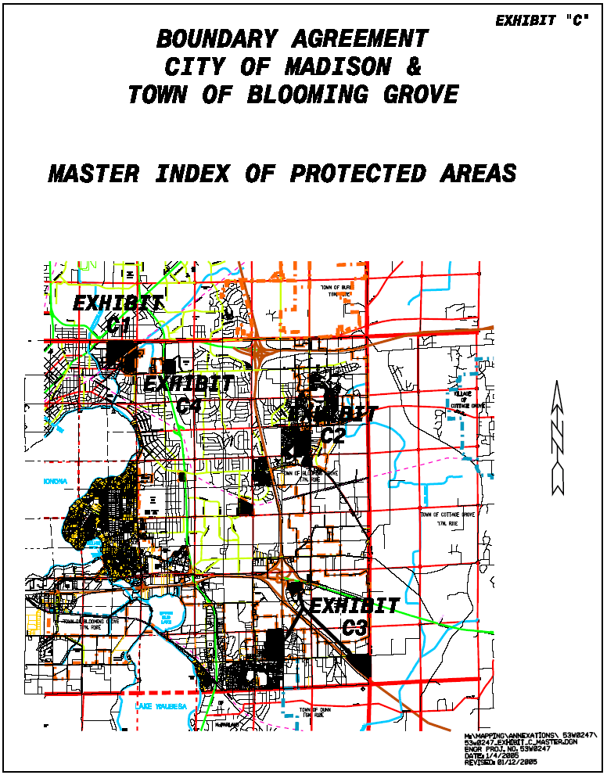

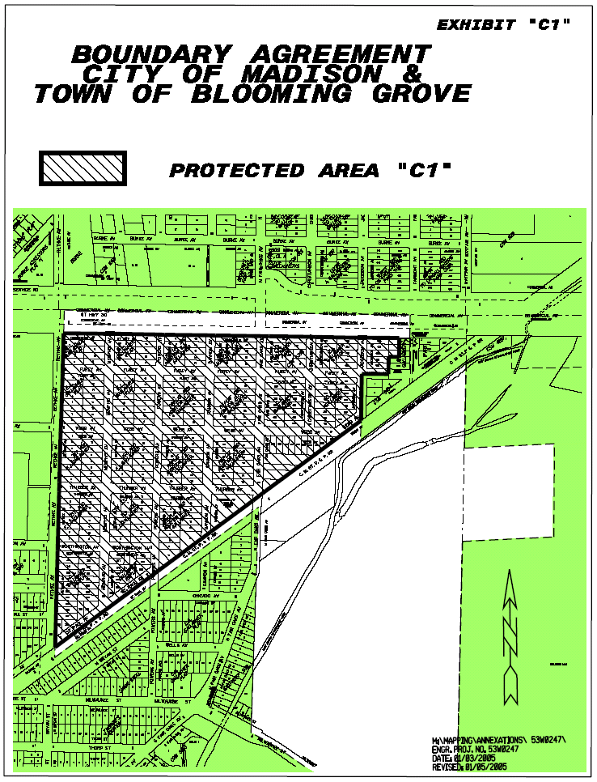

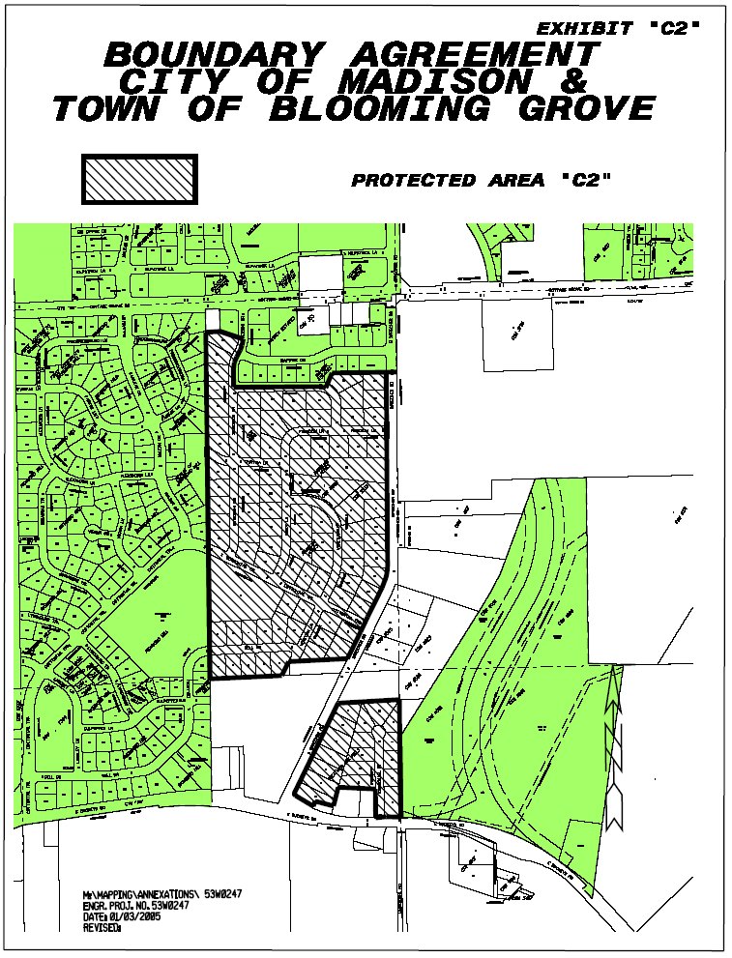

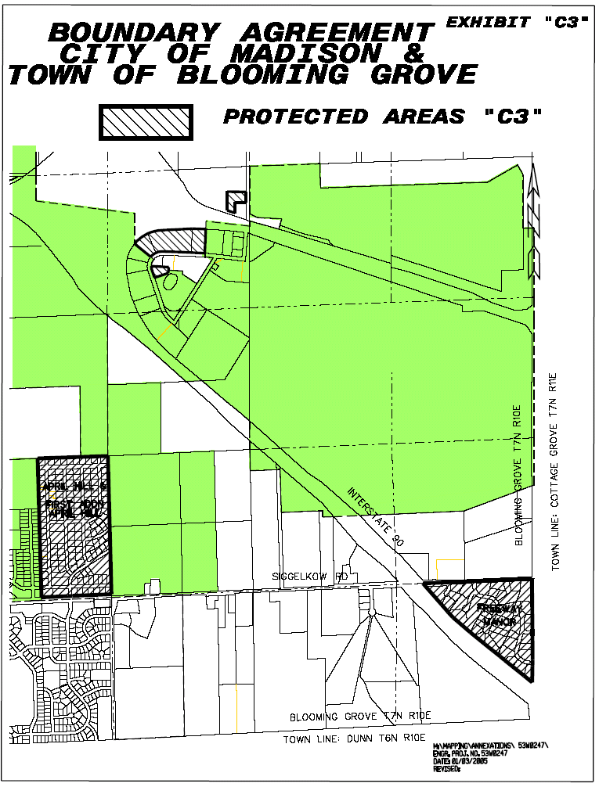

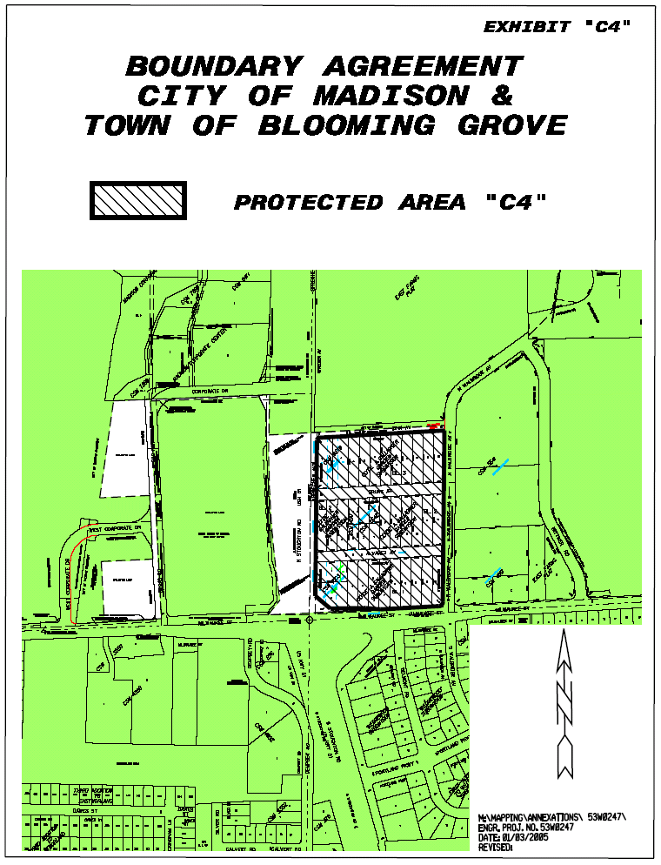
Exhibit D
Description and Map of Rustic Acres

Description of Rustic Acres: All territory in Rustic Acres that has not been annexed to the City of Madison as of the effective date of this Agreement (as shown on Exhibit “D”).
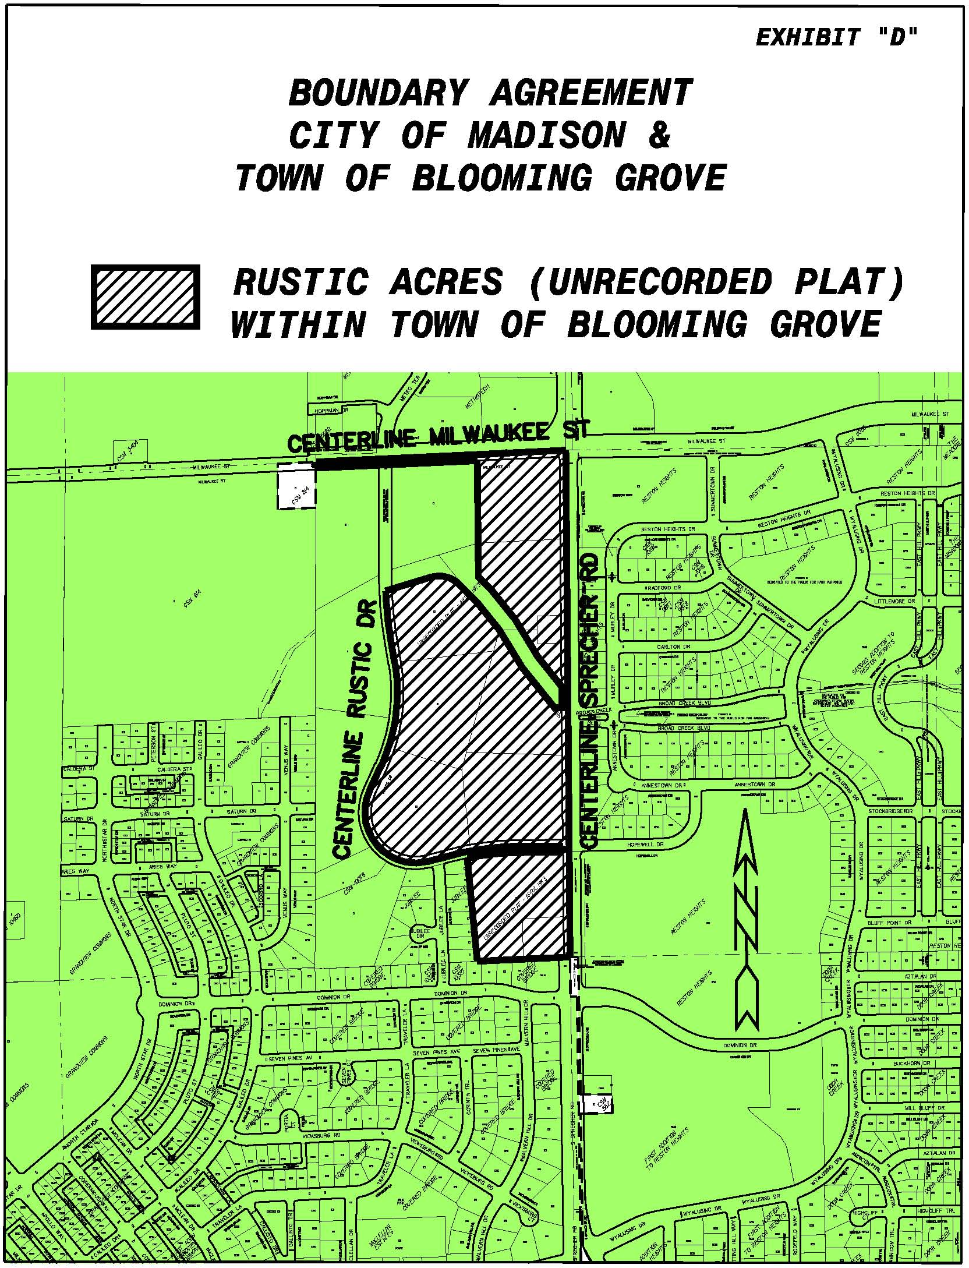
Exhibit E
LEGAL Description and Map of the Development Property

All of that land described in Document No. 858228, in Vol. 598 of Deeds, Pg. 341, Dane County Registry, located in the Northwest 1/4 of the Northwest 1/4 of Section 4, Town 7 North, Range 10 East, and that part of the East 1/2 of the Northeast 1/4 of Section 5, Town 7 North, Range 10 East, bounded on the north by the southeasterly right-of-way line of the Chicago, Milwaukee, St. Paul and Pacific Railroad and bounded on the south by the existing centerline of Milwaukee Street (County Trunk Highway “T”) except those lands described in Document No. 2671809, Vol. 29715 of Records, Pg. 2, and Document No. 1818930, Vol. 5326 of Records, Pg. 77, Dane County Registry, all in the Town of Blooming Grove, Dane County, Wisconsin, to wit:

Beginning at the East Quarter Corner of said Section 5, being also the existing centerline of Milwaukee Street; thence N01°12’06”E (N00°24’E per Doc. No. 858228), 1528 feet to the southwest corner of said lands per Doc. No. 858228; thence N87°05’E, 581 feet to the southeast corner of said lands; thence N00°24’E, 600 feet to the northeast corner of said lands; thence S87°05’W, 581 feet to a the northwest corner of said lands, on the East line of Section 5; thence N01°12’06”E (N00°24’E per Doc. No. 858228) along said East line, 556 feet, more or less, to the southeasterly right-of-way line of the Chicago, Milwaukee, St. Paul and Pacific Railroad;
thence southwesterly along said right-of-way, 846 feet, more or less, to the northeast corner of said lands per Doc. No. 2671809; thence south, parallel with the easterly right-of-way line of Fair Oaks Avenue as described in said Doc. No. 2671809, 300 feet to the southeast corner of said lands; thence S52°04’W along the southeast line of said lands per Doc. No. 2671809, and along the southeast line of said lands per Doc. No. 1818930, 620 feet, more or less, to the East line of the West 1/2 of the Northeast 1/4 of said Section 5; thence southerly along said East line, 1090 feet, more or less, to the existing centerline of Milwaukee St. and limits of the City of Madison;
thence southeasterly and easterly along said centerline and city limits, 1400 feet, more or less, to the point of beginning. Containing 70 acres, more or less.

Tax Parcel Numbers included in description:
0710-042-8680-7
0710-051-8250-6
0710-051-9810-6
0710-051-9860-6

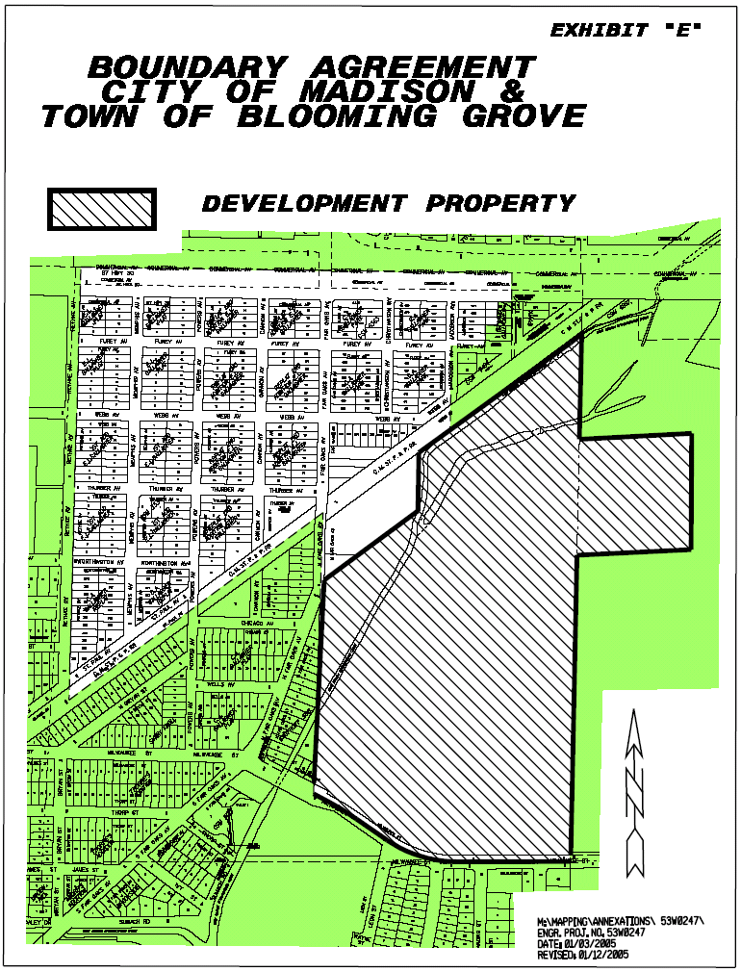
Exhibit F
Joint Zoning Procedure for the Development Property

1. At the request of the Town, the City, or the owner(s) of the Development Property, the City and the Town shall establish a joint committee comprised of three Town members and three City members to establish zoning and related regulations (collectively referred to as “zoning”) over the Development Property for development of the Development Property while it is in the Town (the “Joint Committee”). The City members shall be residents of the City and shall be appointed by the Mayor. The Town members shall be residents of the Town and shall be appointed by the Town Chair.

2. The Joint Committee shall formulate the zoning for the Development Property and shall hold a public hearing thereon. The Joint Committee shall consult with owner(s) of the Development Property about the zoning. Notice of the public hearing shall be given by publication in a newspaper having general circulation in the area to be zoned as a class 2 notice under Wis. Stat. Ch. 985. At the public hearing, an opportunity to be heard shall be afforded to the public, representatives of the Town Board, representatives of the City Council, and the owner(s) of the Development Property. After the hearing, the Joint Committee shall vote on the zoning

3. The governing bodies of the City and the Town shall not jointly adopt the zoning of the Joint Committee unless the zoning receives a favorable vote of the majority of the members of the Joint Committee.

4. If the zoning is acceptable to the City and the Town, it shall be implemented by the adoption of an ordinance by the governing bodies of the City and the Town. The governing bodies of the City and the Town may jointly hold a public hearing, with notice as provided in No. 2 of this Exhibit G, prior to acting on the zoning.

5. In case of a protest against the zoning duly signed and acknowledged by the owners of 20% or more of either of the Development Property, or the owners of 20% or more of the area of land immediately adjacent extending 100 feet therefrom, or by the owners of 20% or more of the land directly opposite thereto extending 100 feet from the street frontage of such opposite land, the zoning shall not become effective except by the favorable vote of 3/4 of the members of the City Council and 3/4 of the members of the Town Board voting on the zoning.

6. The zoning shall be consistent with the public interest and the Town’s land use plan and the City’s comprehensive plan in effect at the time the zoning is established. At the present time, those plans would allow development of the Development Property for residential single-family and multifamily use, including senior elderly housing, and some limited amount of mixed uses including neighborhood commercial uses, and associated improvements, including roads, utilities, parkland, multipurpose trails, wetlands, or other open spaces, ponds, and other governmental uses.

7. If the Parties will be rezoning areas of the Development Property zoned for exclusive agriculture use, such rezoning shall be upon findings that are based upon consideration of the following:

(a) Adequate public facilities to accommodate development either exist or will be provided within a reasonable time.

(b) Provision of public facilities to accommodate development will not place an unreasonable burden on the ability of affected local units of government to provide them.

(c) The land proposed for rezoning is suitable for development and development will not result in undue water or air pollution, cause unreasonable soil erosion or have an unreasonably adverse effect on rare or irreplaceable natural areas.

8. Any zoning of areas of the Development Property that are subject to existing shoreland, wetland or floodplain zoning shall comply with and be at least as restrictive as the standards contained in the existing shoreland, wetland, and flood plain zoning.

9. The City shall administer and enforce the zoning.

10. The City shall have the authority to issue building permits for the Development Property, unless the City agrees to delegate such authority to the Town.

Exhibit G
AUTHORIZING RESOLUTION OF’
TOWN OF BLOOMING GROVE

Exhibit H
AUTHORIZING RESOLUTION OF
CITY OF MADISON

